Literacy  We will continue learning Set 1 sounds in Read, Write Inc. and listening for different sounds in our environment. We will practice orally blending using Fred Talk so we can hear all the sounds in simple words. We will be reading stories based on festivals of light and space. We will talk about the pictures in books and make predictions about a story. In handwriting activities, we will use large and small movements (fine/gross motor). We will talk about the marks we make when we draw and paint. We will write our own names and begin to label objects and pictures with initial sounds. | Look at how bright the stars are!  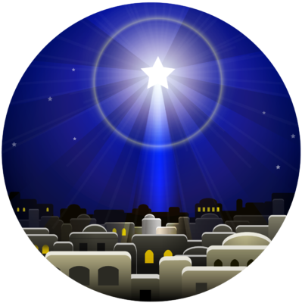 | Maths  We will be focussing on numbers 1 to 5. We will count objects using 1:1 correspondence and learn that when we count, numbers have to be said in a certain order. We will look at groups of objects and begin to say the total. We will be able to subitise and know that there are up to 5 objects without counting them.  We will look at number formation. We will sing lots of fun number songs! Towards the end of the term we will learn about shapes and their properties.
Communication and Language  We will continue to use talking sessions to share our thoughts and feelings about events and exciting experiences. We will create and perform our own stories and use learnt vocabulary in our drawing club sessions. We will develop our confidence to perform to an audience as part of our Nativity show. | Term dates  5th Nov – Guy Fawkes  11th Nov -Remembrance Day  12 – 14 Nov – Book Fair  14th Nov – BBC Children in Need  19th Nov - Production  1st Dec – Christingle making  11th Dec – National Christmas Jumper day  12th Dec – Reception Nativity Performance  Christmas Fair  18th Dec - Christmas Disco | Understanding the World  We will be learning about different festivals of light comparing similarities and difference. We will learn about and perform the Nativity story.  We will share how we celebrate a special festival at home and compare how people celebrated in the past and in different parts of the world. We will look at the importance of maps and create our own from familiar stories.  We will make observations of the sky and investigate how the moon changes.
Physical Development  We will be focussing on ball skills such as catching and throwing and learning how to balance ourselves. We will continue to have our daily Dough Disco sessions to develop our finger muscles. We will continue to practice holding a pencil in a tripod grip and use it with control while developing a dominant hand. We will have daily fine and gross motor activities. | Personal, Social and Emotional Development  This term we will express our feelings about events, stories and situations within the classroom. We will focus on kindness. We will have opportunities to take turns in finding out about how we are the same and how we are different in relation to celebrations. We will celebrate our differences. We will attempt new tasks and begin to understand that mistakes are a part of learning. Our Jigsaw PSHE unit is called: Celebrating Differences. | Expressive Arts and Design  We will be focussing on using different textures and materials to create. We will use a range of tools and materials to create own our models e.g. construction, junk modelling. We will retell familiar stories and create art inspired by them. We will learn a range of new songs and perform them in our Nativity show.

