Communication and Language  We are continuing to work on developing awareness of sounds and rhythms (essential pre-reading skills which prepare our pre-schoolers for learning phonics). We will use games, songs, and rhymes to explore patterns of sound, and we will investigate the sounds we can make with our bodies and with instruments. We will also be continuing to use our very best manners at snack and lunch times particularly: “please,” “thank you,” and “it’s not to my taste today.” Before the end of term, we will be putting on a Christmas performance of some of the songs and rhymes that we learn this term – we hope very much that you will be able to come. | Term dates 3rd November - 19th December 2025  Please could your child bring a water bottle (named), a change of clothes (named!), a waterproof coat (named!), and wellies (named!) every day. Remember to check your child’s tray at pickup for fabulous creations, and have a look in their learning journal to see what we’ve been up to. Any concerns, questions, successes or suggestions, please do come and share with us!  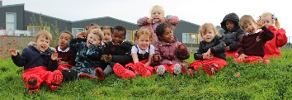 | Literacy  This term, we are going to be enjoying books about polar regions, winter, and Christmas. We will continue to use our felt board to help us retell some of these stories, and we will add in some puppet play too. You can support at home by reading and discussing books with your child daily. Every Tuesday afternoon, we go to the school library, where the children chooses a book to take back to class. This term, we hope to send that book home along with a reading record for you to record the books that you read with your child. Please ensure the library book is returned the next Monday or Tuesday, ready for the children to pick another one. If you have any suggestions you for books that your child has particularly enjoyed, do please pass them on!
Personal, Social, and Emotional Development  We will be making lots of new friends this term, learning to express ourselves with words, and showing awareness of other peoples needs as we settle into our preschool rhythms and routines. We will explore topics including my family, foods I like, and learning about our emotions through the story Owl Babies. Please send in pictures of your pre-schooler’s family, and their favourite food for us to use in our learning and classroom displays. | Expressive Art and Design  Our pre-schoolers will be using different materials to make creative works – markers, pens, and paint before we see where the creative juices lead us! We will explore texture, colour, and application strategies. We will be singing lots of nursery rhymes and songs, gradually building up a repertoire that the children can perform on our outdoor stage themselves. | Understanding the World  We will use the topic of Polar Express to investigate winter. We will look at the different birds and animals associated with polar regions and winter, and we have great plans for building an indoor igloo – we’ll see how that pans out! The children will have the opportunity to talk about special times in their lives, investigate how much they have changed since they were a baby, and family life.
Physical Development  Gross motor skills (big body movements) will continue to be developed in our adventures in the Wildlands this term on Mondays, Wednesdays, and Fridays (please make sure your child has appropriate clothing and footwear on these days in particular!). We will continue to use fine motor trays to engage the muscles in their hands and arms to ready them for later writing. | 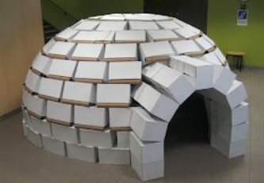  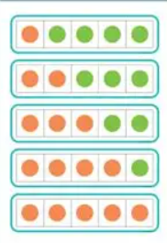 | Maths  In this term’s learning, we will be looking at amounts to 3 through subitising. We have our calendar on the wall and our countdown to Christmas to show the passage of time, and to continue to think about the concepts of more and less. We will continue to look at and play with patterns and sequences, and will be using a self-registration board and self-regulation board to embed the idea of a 5-frame, which we will continue to use through pre-school.

